Higher Diploma in Information Technology

Object Oriented Programming (Java)

# Year 1 Semester 2 – 2024

**Lab 8 Classes and Objects**

# Intended Learning Outcomes:

At the end of the class the students should be able to:

* To Create Model Classes
* To use Constructors in java Programs
* To invoke model classes in your main method

1. Create a class called Bicycle in Model Package which contains following methods and attributes.
   * Attributes o Gear o Speed
   * Methods o Constructor -takes values respectively.

o

applyBrakes(double decrement)reduce the speed. o

speedup(double increment)increase the speed.

o toString()-print the details about the Bike

1. Design the following UI Under the Views package

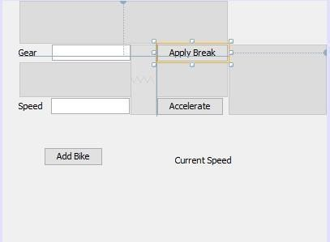

1. Create an Object under the event of Add bike and display a message box 4. Call the Speed up and Brake Method respectively.

Page **1** of **1**